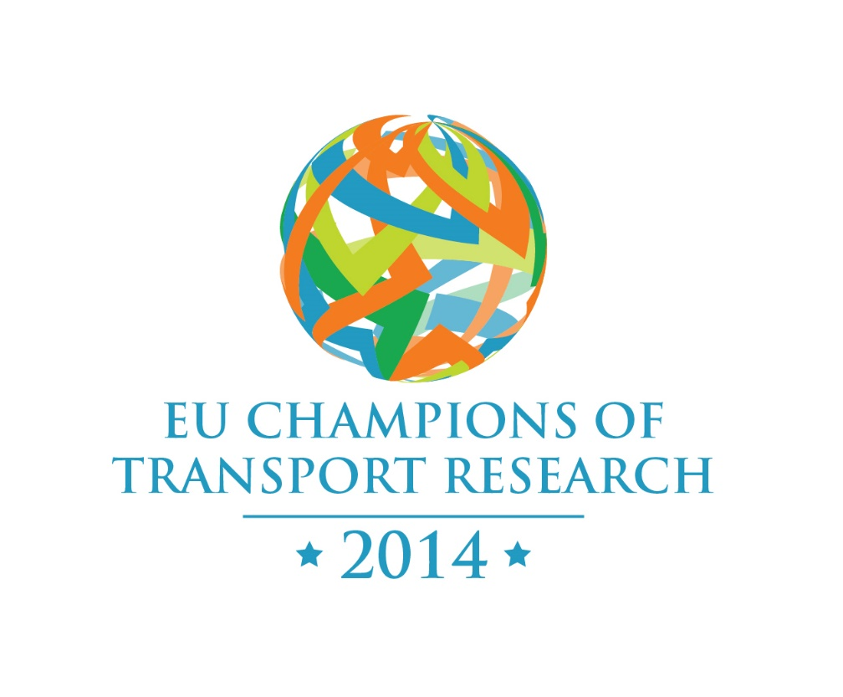**

2016

*TRA Visions 2016*

*EU Champions of Transport Research Competition*

|  |  |
| --- | --- |
|  |  |
|  |  |
|  |  |
|  |  |

*Researcher Competition Rules,*

*Guidelines and Evaluation Criteria*



TRA VISIONS 2016

is funded by

the European Union



# Contents

Contents i

1. Introduction 1

2. Timeline (See also Appendix I) 1

3. Competition rules 1

4. Submissions 3

5. Evaluation Process 3

6. Evaluation Criteria 3

7. Prizes and awards 4

8. Further Information 4

Appendix I: TRA VISIONS-2016 Researchers Competition Timeline 5

# Introduction

Transport Research Arena 2016 will be the second time that the EU Champions of Transport Research Competition has run. The competition recognises and celebrates leading researchers who are, or have recently been, contributing to surface transport EU-funded projects. Successful candidates will have to demonstrate excellence and proven impacts in their field of research.

This competition will provide a platform to further disseminate knowledge and results from research projects in Surface Transport, promoting future synergies and further development of innovative ideas, in line with the strategic objectives of the TRA stakeholders. The Champions of Research Competition will act as a showcase for the very best EU-funded research and encourage the identification of current and future leaders in the field.

The competition will be promoted through the stakeholders in the consortium; national contact points; targeted contact co-ordinators; participants in EU-funded transport projects and the TRA conference itself.

Candidates will apply through the TRA Visions 2016 website (<http://www.travisions.eu>) using templates which are available on the website.

# Timeline (See also Appendix I)

* Competition launch March 2015
* Submission of entries deadline 30 September 2015
* Announcement of shortlisted entries no later than 21 Dec 2015
* TRA conference: April 18-21, 2016

# Competition rules

1. Entries must be based (wholly or in part) on research funded by the EU between 2005 and 2015. Research with a mix of EU and other funding is acceptable but if the EU contribution is small the submission maybe given a lower weighting.
2. Previous winners may not re-enter with the same theme. Previous unsuccessful entrants including finalists are encouraged to re-enter especially if they have strengthened their case since the last competition.
3. Only one entry per person. Group or individual entries are eligible; however only one nominee will be supported to travel to TRA 2016 (see note ii)
4. The deadline for submission of entries is 30/09/15 at midnight Central European Time. Late submissions maybe accepted at the organising committee’s discretion. If accepted the organising committee reserves the right to give submissions a weighting penalty. The organising committee has the right to delay the deadline.
5. All entries must be no longer than 5 sides of A4. Entrants should upload supporting documentation as appendices. It is required that submissions are in the form of a PDF file. More details can be found on the web.
6. Entrants must provide all requested details when entering the competition, as outlined in the Application Form.
7. Only entries submitted within the online submission section of the TRA Visions 2016 website will be accepted.
8. Entrants must comply with all rules to be eligible for the prizes, certificates and contributions towards their accommodation and travel expenses.
9. No responsibility is accepted for ineligible entries or entries made fraudulently.
10. Entrants will be deemed to have accepted these rules and to agree to be bound by them when entering this competition.
11. The competition organisers do not accept any responsibility for late or lost entries due to poor performance of the Internet – applicants are advised to apply as early as possible. Proof of sending is not proof of receipt.
12. Entrants must not be directly related or affiliated to the individuals participating in the TRA VISIONS 2016 (Project No SEP-210141464) consortium.
13. If an entry is shortlisted for the final, the entrant is required to attend the TRA 2016 Conference and award ceremony. In the case of a group entry at least one member must attend.
14. If an entry is shortlisted for the final, the entrant maybe required to give a short presentation based on the research work of their submission. In addition the entrant will be expected to cooperate in a timely manner with the competition organisers for reasonable requests for additional material to support the awards ceremony.
15. The organisers will provide a contribution towards the accommodation and travel expenses to the TRA 2016 Conference in Warsaw, Poland for the invited winners.
16. Entrants are responsible for organizing their own accommodation and travel to and from the conference in Warsaw.
17. All listed team members on the entries shortlisted for the final will be given a certificate acknowledging their achievement (see note iii).
18. A winner will be selected in each mode; road, rail, waterborne and cross modal transport. Each winner will be presented with a trophy.
19. A “winner of winners” may be selected from the mode winners.
20. Winners will be acknowledged on both the TRA Visions and the TRA 2016 websites and may be acknowledged on the websites of the project consortium members.
21. The Judges decision is final in every situation including any not covered above and no correspondence will be entered into.
22. The Judges and competition organisers reserve the right to have discretion regarding the rules.
23. The organisers reserve the right to cancel the competition at any stage, if deemed necessary in their opinion, and if circumstances arise outside of their control. In such circumstances, no costs will be refunded.
24. The organisers reserve the right not to award a prize in one or more categories in the unlikely event that the Judges decide that no entry is of sufficient standard.

Notes

i) There are no specific educational, qualification or nationality requirements but as a guide it is envisioned that entrants will be senior researchers well recognised in their field.

ii) The competition is primarily aimed at individual champions but this does not exclude a joint entry from two or more senior researchers working on a collaborative project. In this case the relative contributions of the senior researchers must be provided as well as the benefits gained from the collaboration. When assessing output the judges will take in to consideration the number of senior researchers for any submission.

iii) The organisers recognise that research is often a team effort and are keen to recognise the work of all team members. Shortlisted candidates may provide a list of the research group who have supported their work.

# Submissions

Entrants must select the most appropriate transport mode for their submission. Submissions need not be exclusively constrained to a single transport mode but can only be consider once.

1. Road
2. Rail
3. Waterborne
4. Cross Modal

The submission must provide evidence for one or more of the following for the entrant based upon the entrant’s EU funded transport related research portfolio from the last ten years.

1. Scientific Impact,
2. Policy development,
3. Public Outreach,
4. Economic Impact.

In addition the submission must provide a 5 year plan for exploitation and development of the transport related research.

All submissions must be in English

# Evaluation Process

The evaluation is a three stage process. Firstly all entries will be reviewed for eligibility. Then the remaining submissions will be reviewed against the selection criteria and a short list will be produced for each transport mode. Entrants will be notified if they have been shortlisted or not by 21 December 2015. The shortlisted entries will be reviewed in further detail by an expert panel in order to identify a winner for each mode, and an overall ‘winner of winners’. The results will be announced during the TRA 2016 Conference.

# Evaluation Criteria

Entries will be evaluated on the evidence provided and the scientific and public impact of their research from EU-funded projects. Consideration will be given to

* resources available
* amount and proportion of EU-funding
* impact on national, EU and global levels
* relevance to transport

# Prizes and awards

Winners will be announced during the TRA VISIONS 2016 Conference and prizes will be presented at an award ceremony during the Conference.

# Further Information

For further information, please visit [www.travisions.eu](http://www.travisions.eu) where you will be able to find a link to the TRA Visions Champions of Transport Research competition, frequently asked questions and research area specific information. Alternatively you can contact the TRA VISIONS 2016 Champions of Transport Research Competition organiser Dr Alistair Greig at [a_greig@meng.ucl.ac.uk](mailto:a_greig@meng.ucl.ac.uk).

# Appendix I: TRA VISIONS-2016 Researchers Competition Timeline

**Dec 2015**

**Oct 2015**

**Aug 2015**

**Sep 2015**

**Nov 2015**

**Mar 2016**

**Apr 2016**

**Mar 2015**

**Apr 2015**

**Dec - 2015**

**Final evaluation of submitted projects. Results announced**

***Call for Ideas****.* This is the registration period where all the participants are invited to register and submit their projects

Initial evaluation

Preparation for conference and award ceremony

**30 - Sep - 2015**

**Deadline for proposal submission**

**March - 2015**

**Initiation of Academic Contest**

**18-21 Apr 2016**

**TRA VISIONS 2016 Award Ceremony**